Velolab

*By NickQZ (*[*https://github.com/NickQZ*](https://github.com/NickQZ) *)*

Current Site:

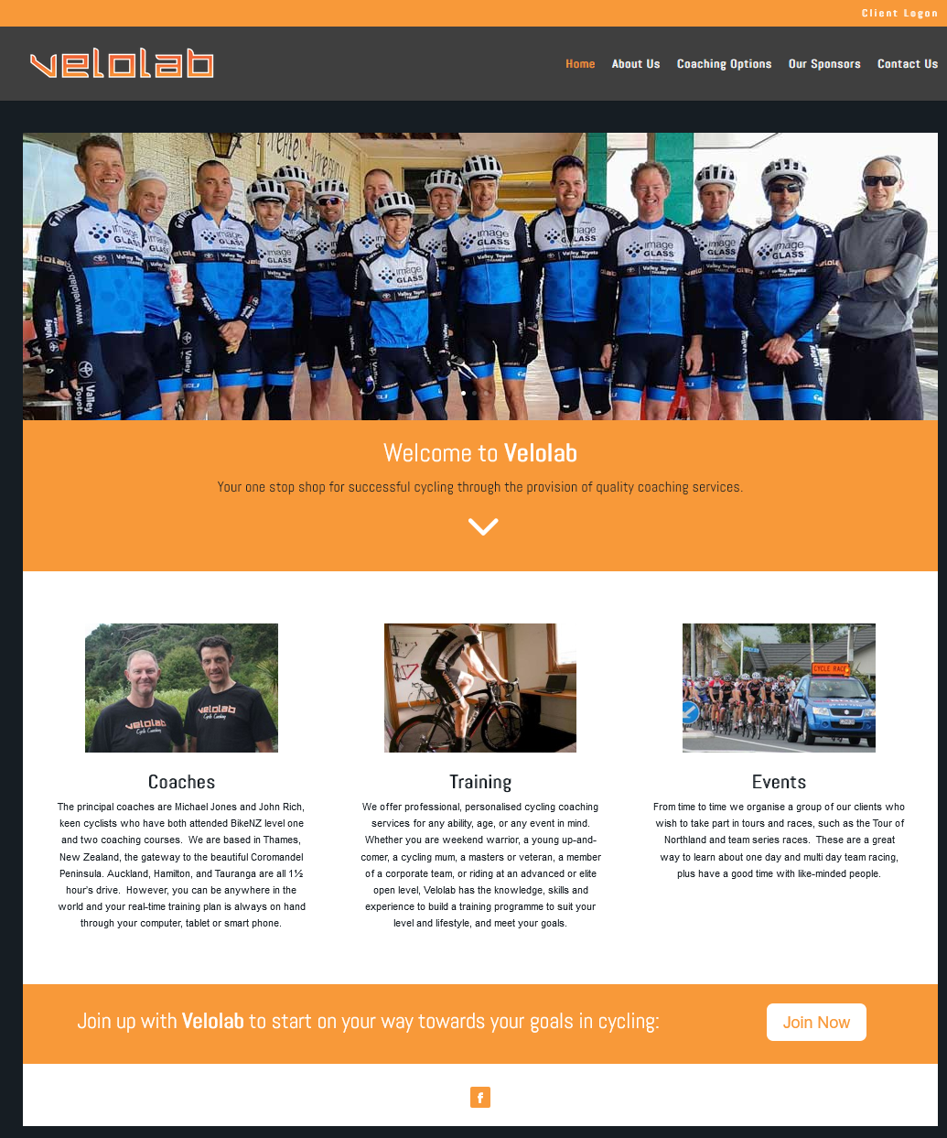Home Page:

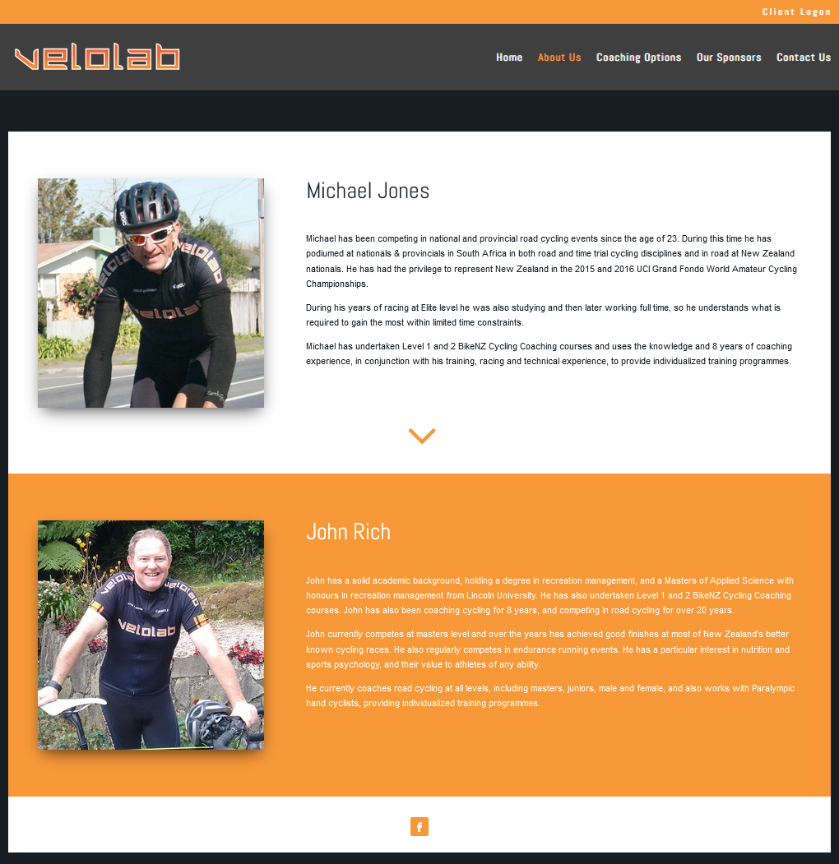About Us Page:

Coaching Options Page:

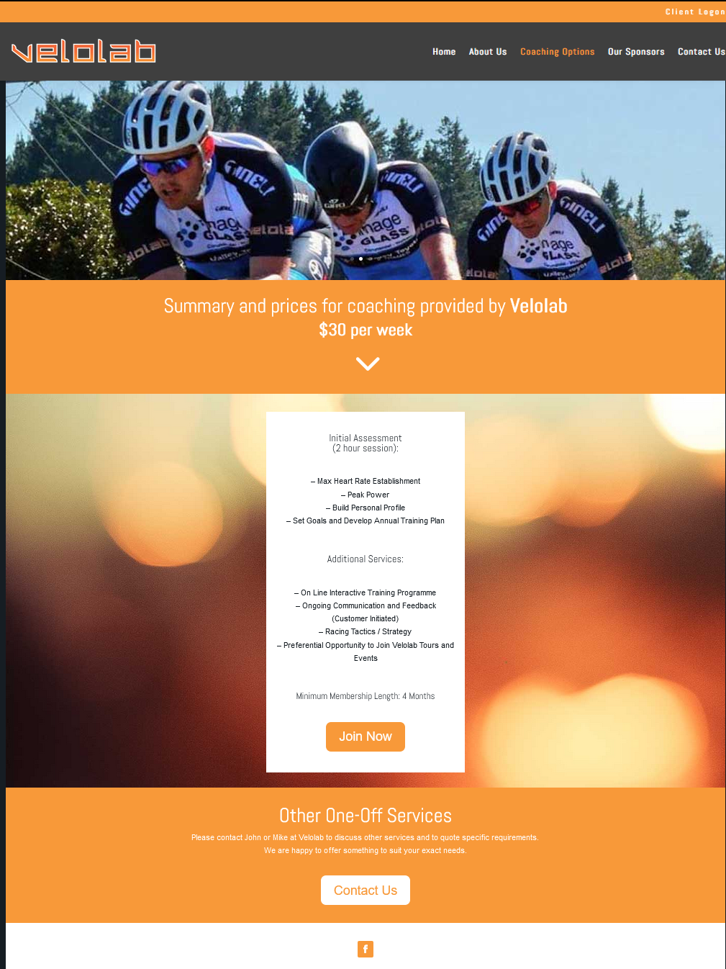

Contact Us:

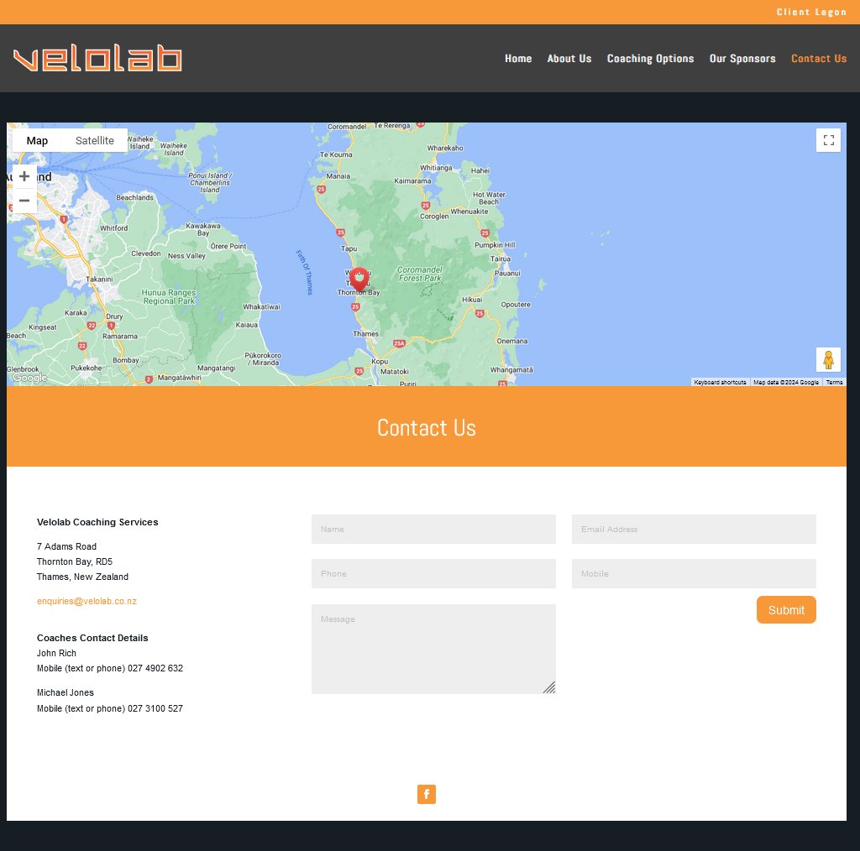

The existing website design was outdated and required a comprehensive redesign. Velolab© approached me to develop a modern aesthetic for the company's website. Below are the design concepts I created using Canva ©.

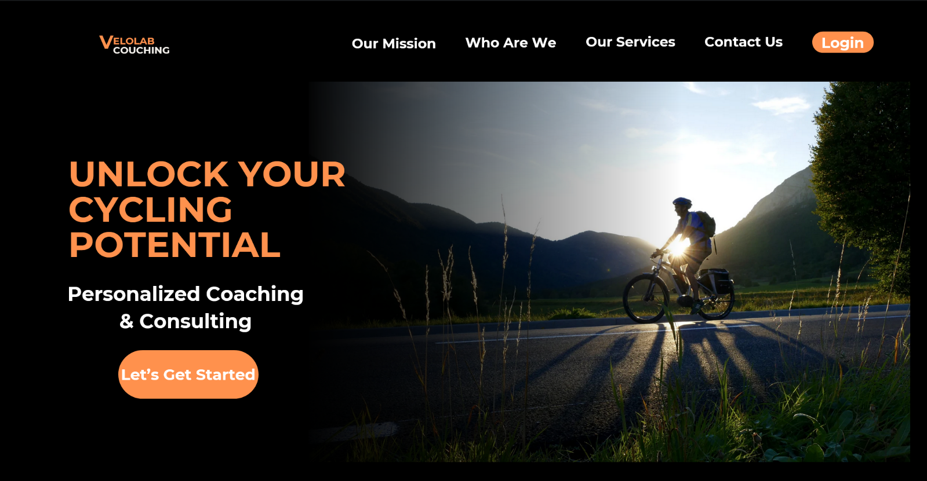Mock Designs:

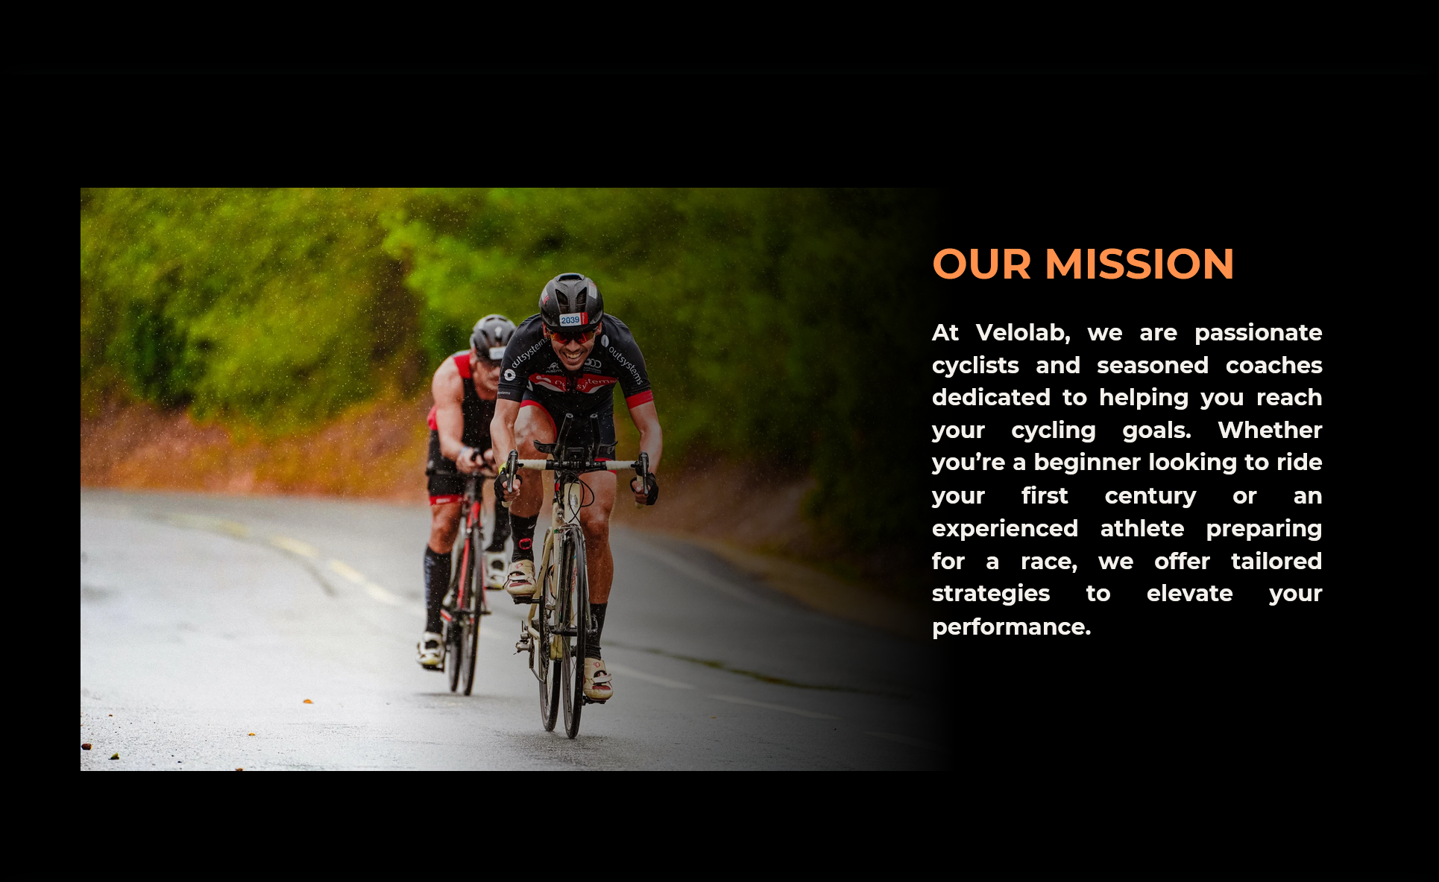

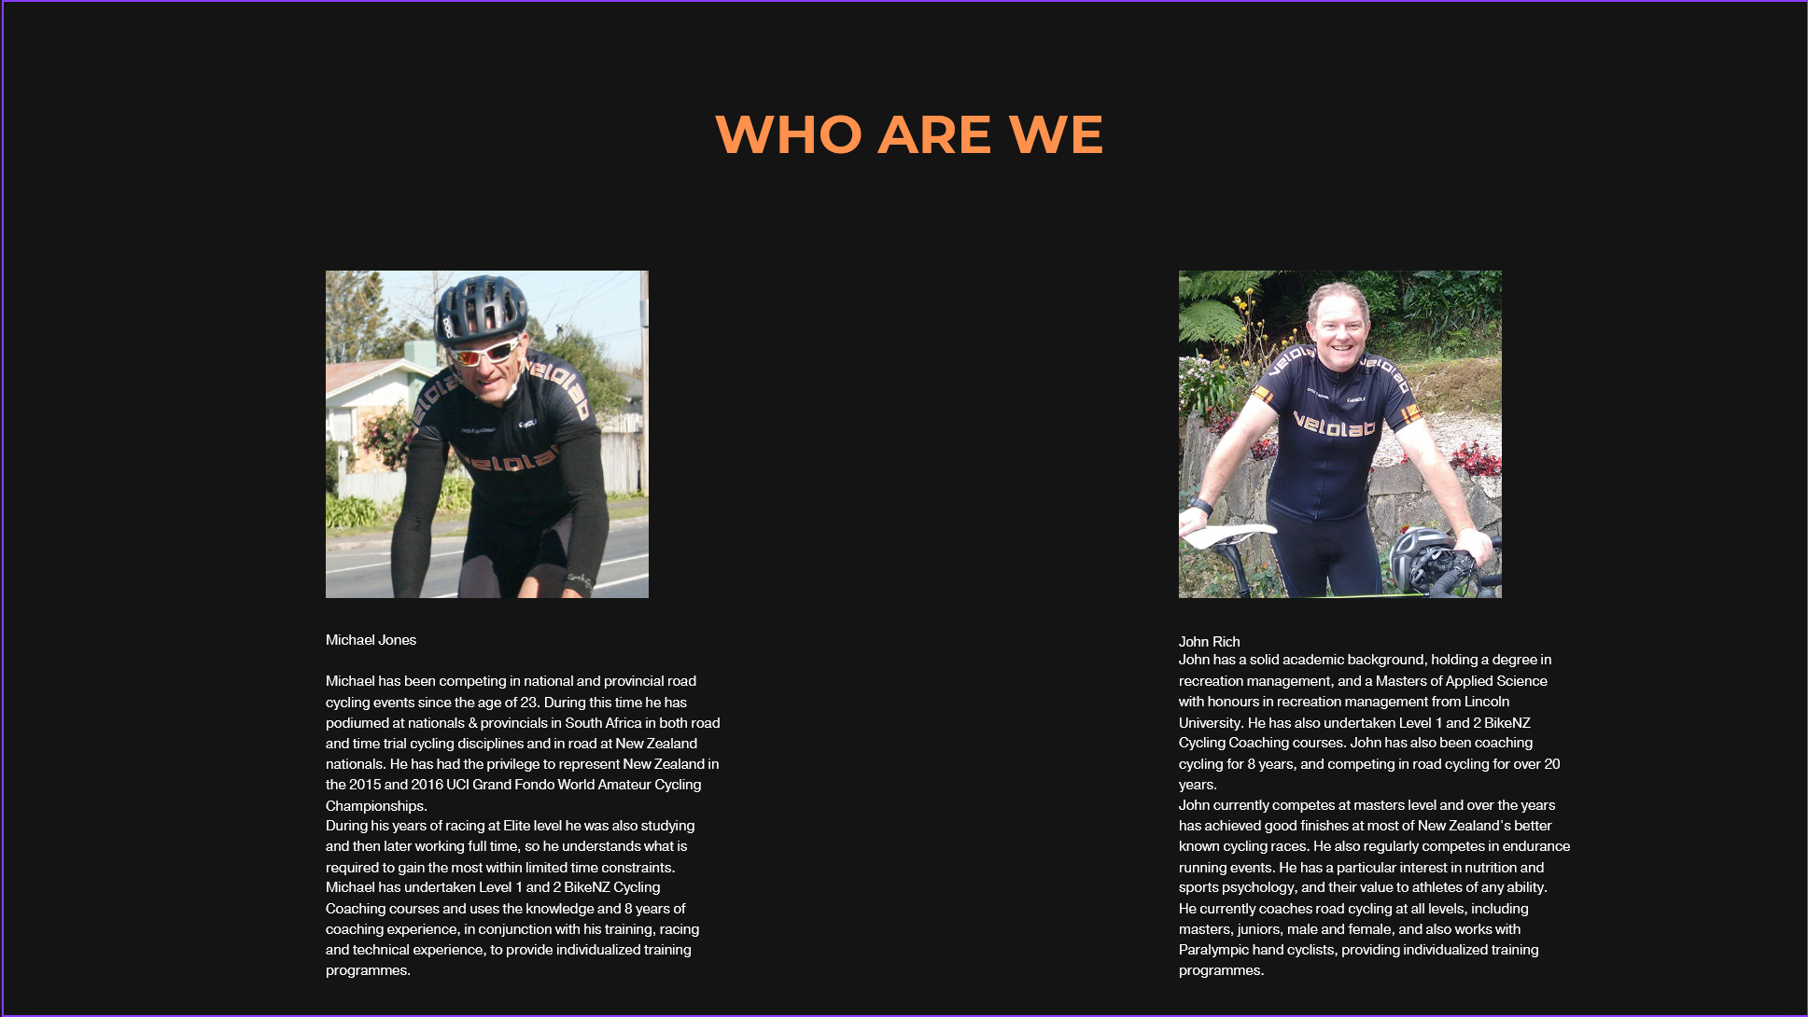

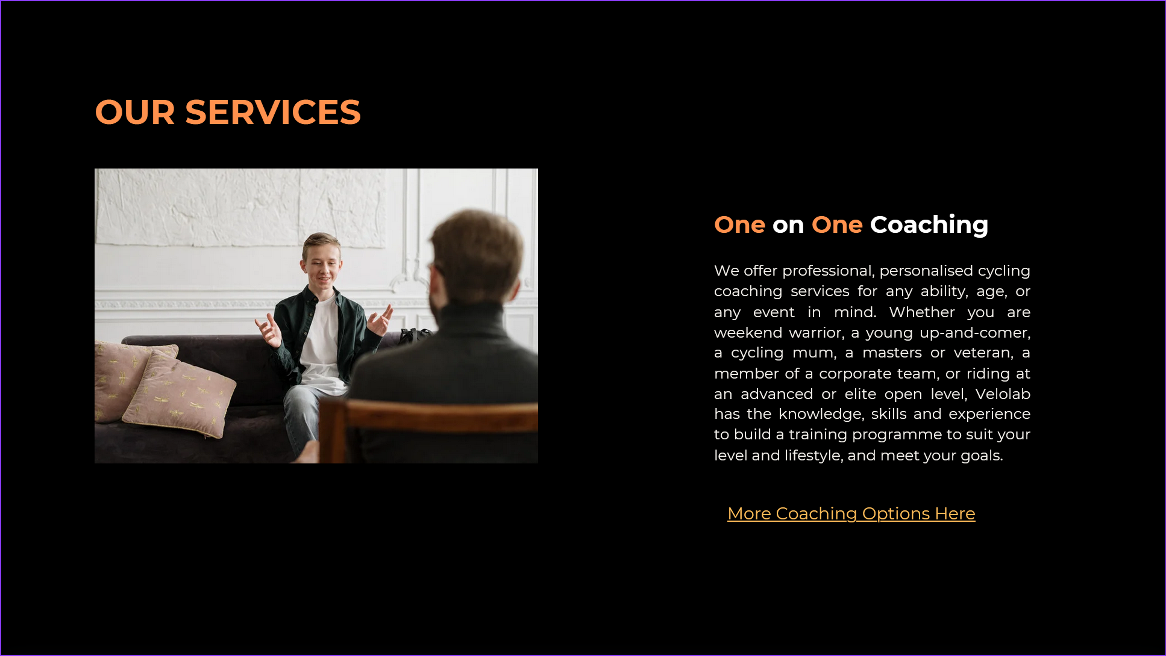

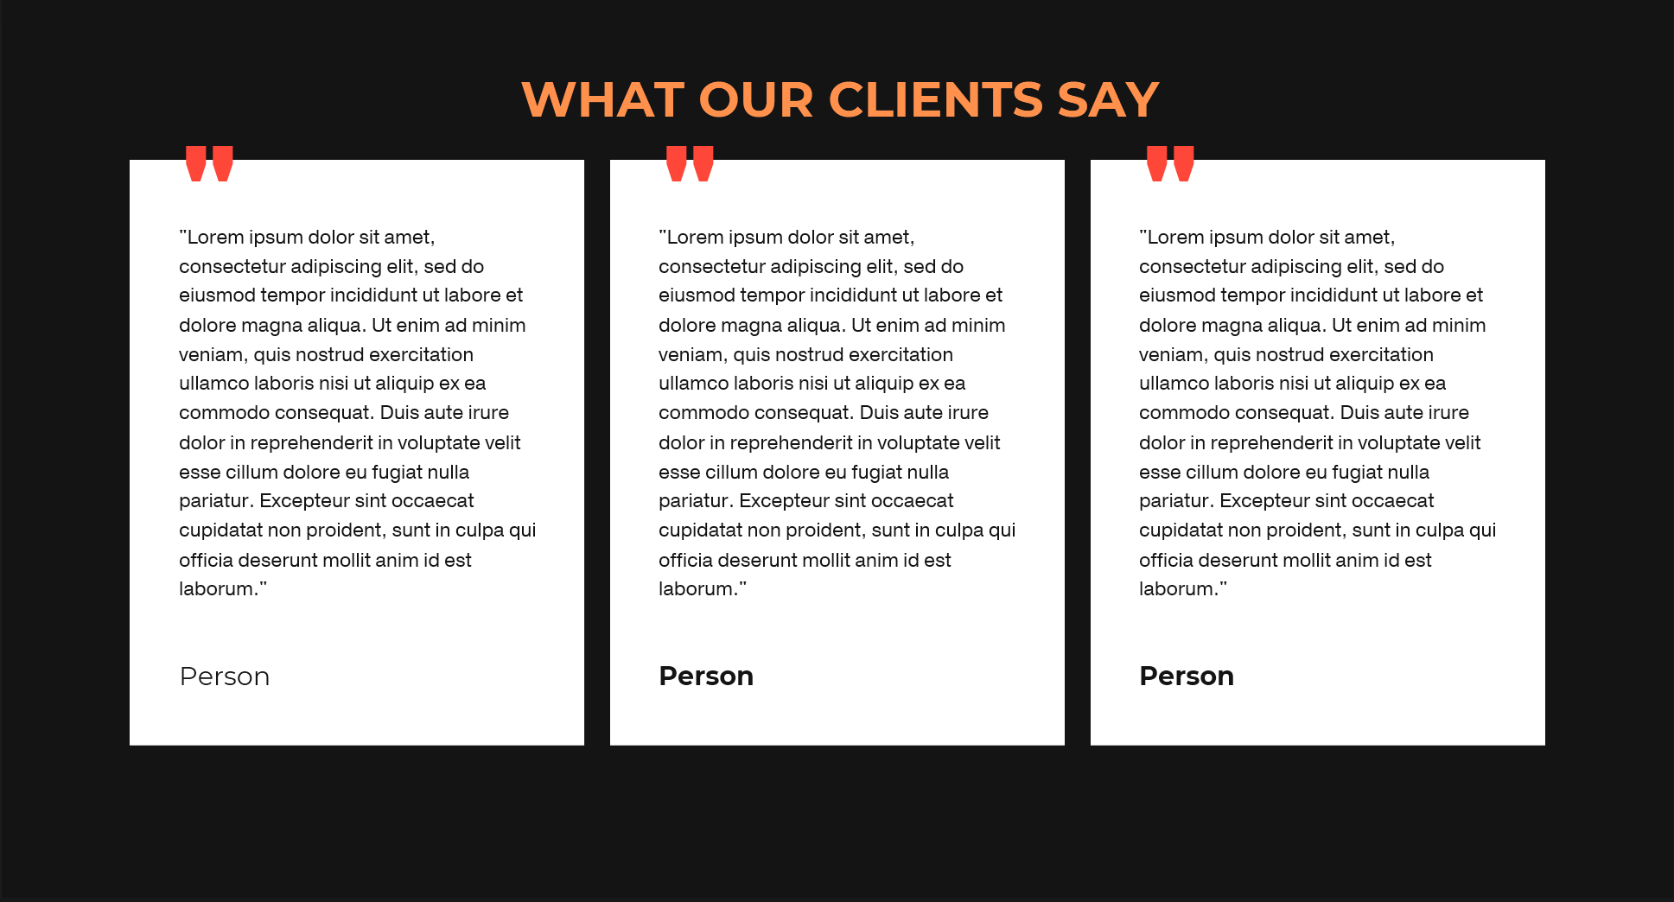

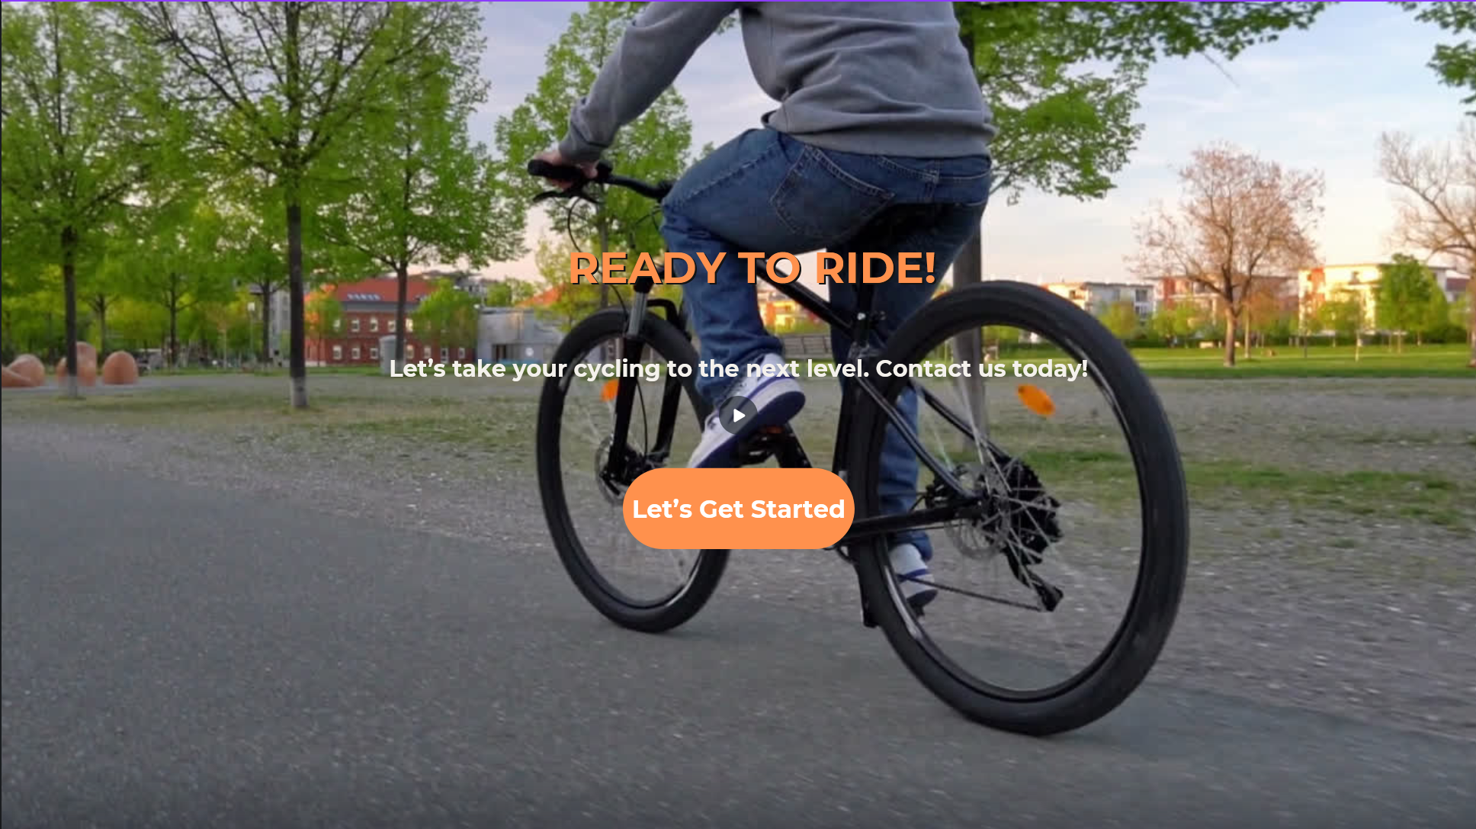

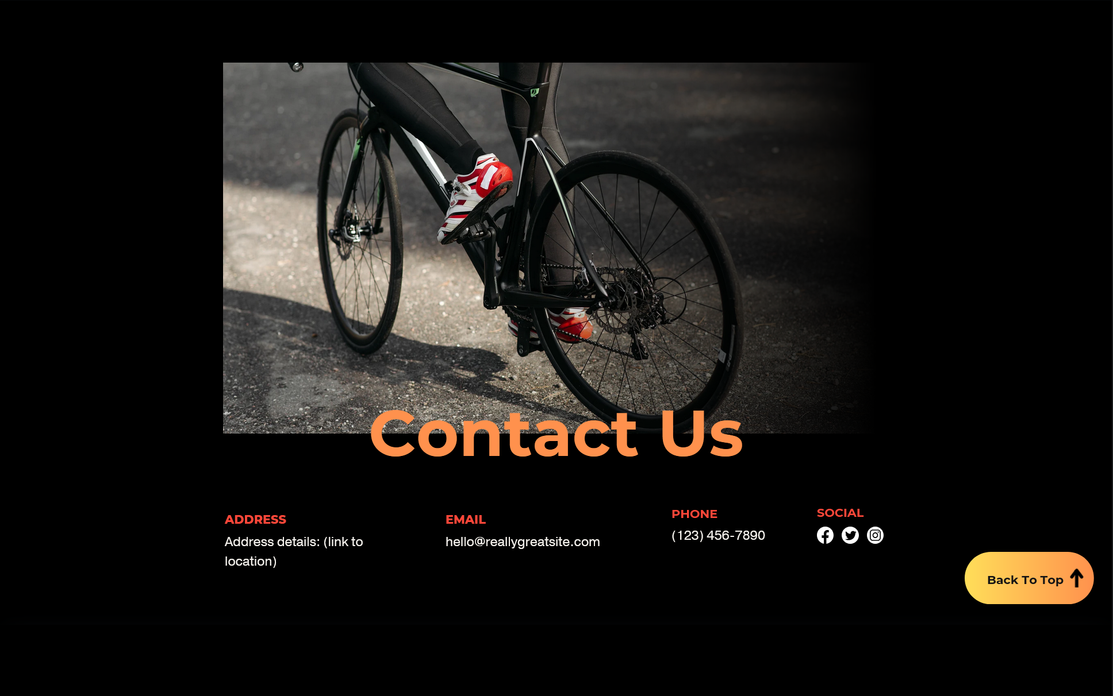

All the proposed designs were presented to the client, who approved them with the stipulation that all images from the original site be reintegrated into the new layout.